Practical No. 13
Aim : Write a user define function to implement following features :
Function without argument, Function with argument, Function returning value
Name : Danish Altaf Solkar | Class : CO - B
Enrolment no. : 24111590805 | Batch : 2

Code :-

#Create function
def myFunction():
print("Welcome to AI-ARKP")

myFunction() #Calling a Function

#Function with argument
def fnsum(a,b):
print(f"Sum of {a} and {b} is {a+b}")

fnsum(85,99) #Calling fnsum

#Function returning value
def fnpercentage(m,t):
p = (m/t)*100
return(p)

fnpercentage(8,12) #Calling fnpercentage

OUTPUT :-
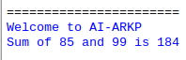

2) Write a python function that takes a number as a parameter and check the number is prime or not

Code :-

def prime(p):
if p<=1:
return f"{c} is not a Prime number"
for i in range(2, p):
if p% i == 0:
return f"{p} is not a Prime number"
return f"{p} is a Prime number"

OUTPUT :-
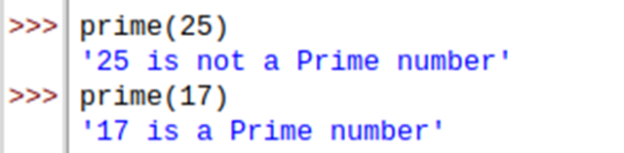

3) WAP to calculate the factorial of a number (a non-negative integer). The function accepts the number as an argument.

Code :-

def factorial(f):
if f == 0:
return 1
else:
return f * factorial(f-1)

OUTPUT :-
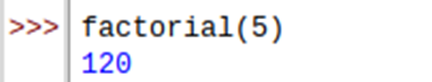

4) WAP that accepts string and calculates the number of upper case letters and lower case letters.

Code :-

def letters (str):
u = 0
1 = 0
for i in str:
if i.isupper():
u += 1
elif i.islower():
1 += 1
return u, 1
u, 1 = letters ("HelloWorld")
print("Uppercase letters:", u)
print("Lowercase letters:", 1)

OUTPUT :-


